**Program-3: Write a JavaScript code that displays text “TEXT- GROWING” with increasing font size in the interval of 100ms in RED COLOR, when the font size reaches 50pt it displays**

**“TEXTSHRINKING” in BLUE color. Then the font size decreases to 5pt.**

**Html:**

<!DOCTYPE html>

<html>

<head>

<title>Assignment-3</title>

</head>

<body>

<style>

p {

position: absolute;

right:550px;

bottom: 450px;

transform: translate(-50%, -50%);

}

</style>

<link rel="stylesheet" href="Assignment3.css">

<title>Program3</title>

<header>

<nav>

<a href="/html">HOME</a> |

<a href="/html">PLACES</a> |

<a href="/html">GALLERY</a> |

<a href="/html">ABOUT US</a>

</nav>

</header>

<h2><u>BTS</u></h2>

<p id="demo"></p>

<script>

var var1 = setInterval(inTimer, 500);

var fs = 5;

var ids = document.getElementById("demo");

function inTimer()

{

ids.innerHTML = 'BTS';

ids.setAttribute('style', "font-size: " + fs + "px; color: #00BFFF");

fs += 5;

if (fs >= 50)

{

clearInterval(var1);

var2 = setInterval(deTimer, 500);

}

}

function deTimer()

{

fs -= 5;

ids.innerHTML = 'BTS';

ids.setAttribute('style', "font-size: " + fs + "px; color: #DF0101");

if (fs == 5)

{

clearInterval(var2);

var1 = setInterval(inTimer, 500);

}

}

</script>

<title>BTS</title>

<img src="C:\Users\Hemab\OneDrive\Pictures\BTS.jpg" alt="BTS" width="300" height="350">

<br>

<h3>by<a href="/html"> Hema</a></h3>

<article>BTS or Bangtan Boys is a South Korean boy band made up of seven members. They were created by Big Hit Entertainment in 2013. The members include RM, Jin, Suga, J-Hope, Jimin, V, and Jungkook. The group debuted on June 13, 2013 with their EP 2 Cool 4 Skool."Dynamite" is a song recorded by South Korean boy band BTS, released on August 21, 2020, through Big Hit Entertainment and Sony Music Entertainment. It is the band's first song fully recorded in English."Dynamite" debuted at number one on the Billboard Hot 100 chart, becoming the band's first number-one single in the United States and making BTS the first all-South Korean act to top the Hot 100. It garnered the band their first Grammy nomination at the 63rd Annual Grammy Awards, for Best Pop Duo/Group Performance, and made them the first Korean pop act to be recognized by the Recording Academy.</article>

<br>

<h3><u> Reviews</u></h3>

<section>

<strong>Popular Social Media artists</strong>

<br>

<stong> Keerthana</strong><img src="C:\Users\Hemab\OneDrive\Pictures\R1.PNG" alt="rating";>

<br>

<strong> My most fav popular boy band!!</strong><br>

<hr>

<strong>BUTTER MV</strong>

<br>

<stong>Anu</strong><img src="C:\Users\Hemab\OneDrive\Pictures\R2.PNG" alt="rating";>

<br>

<strong>Amazing MV!!</strong><br>

<hr>

<strong>Most Liked MV in Youtube</strong>

<br>

<stong>Deepthi</strong><img src="C:\Users\Hemab\OneDrive\Pictures\R3.png" alt="rating";>

<br>

<strong>BTS MV's are AWESOME!!</strong><br>

<hr>

</section>

<footer><nav>

<a href="/html">HOME</a> |

<a href="/html">PLACES</a> |

<a href="/html">GALLERY</a> |

<a href="/html">ABOUT US</a>

</nav>

<br>

<strong><i>Copyright &copy; 2020-2021 by HEMA BY</i></strong>

</footer>

</body>

</html>

**CSS:**

p {

position: absolute;

right: 350px;

bottom: 550px;

transform: translate(-50%, -50%);

**SNAPSHOTS:**

**1.**

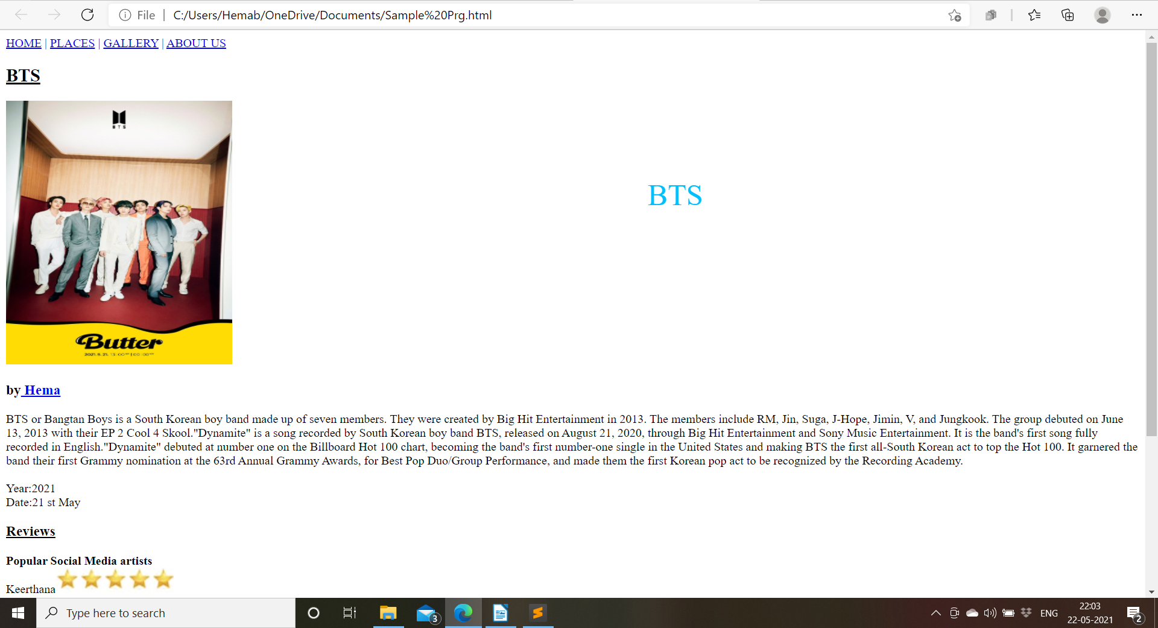

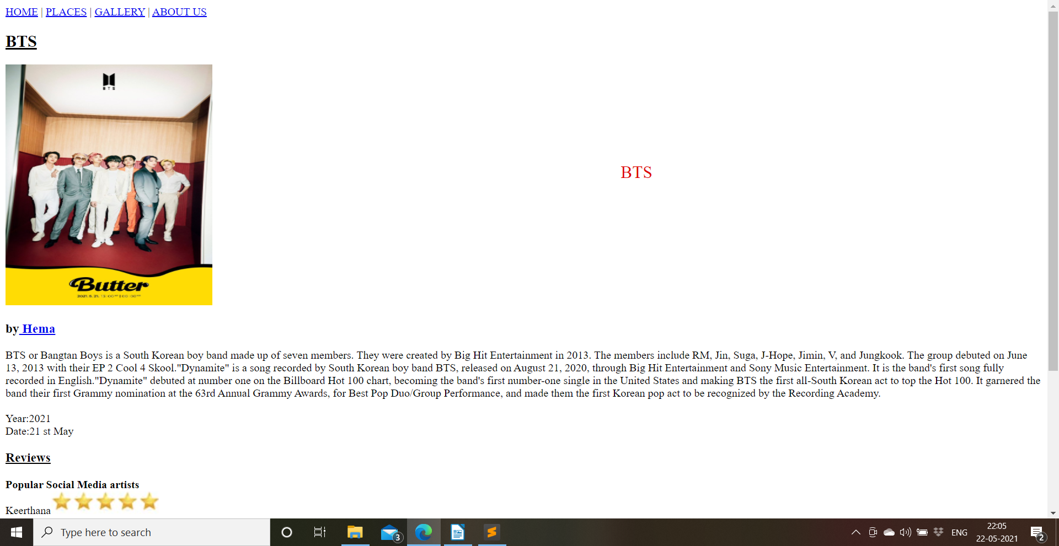**2.**

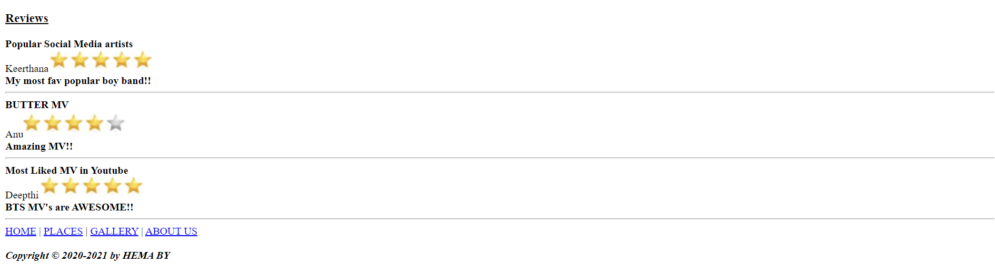3.